Manual Changes by amy.steuart
5820-0097-1T LOT 6 SUNLEE FREDERICKSON, WA 8/4/2021 7:55:08 AM
LIST # L4-1 " SPECIAL LONG SPANS " GRAY PRIMER
MARK QTY JOIST TYPE LENGTH BCP TONS WT/EA DEPTH TIME TC/BC JOIST STAMP
G13 1 50G8N21.1/12.4K5.1 62-2 7 3.29 6580 50 19.352 6056/6056 8/4/2021 7:53:01 AM
1 3.29 19.352
*** MATERIAL REQUIREMENTS ***
SECTION (LEGACY) DESCRIPTION TONS CHANNEL FEET ANGLE FEET
CW40BA (C60) 1.5 x 1.926 x .218 0.0534 33.031
2018 (19) 2 X 2 X .188 0.0267
A40B (A40) 2.3750 x 0.218 0.0350 21.708
2525 (27) 2 1/2 x 2 1/2 x .250 0.0437
3022 (32) 3 x 3 x .227 0.0479
3025 (33) 3 x 3 x .250 0.0262
3028 (34) 3 X 3 X .281 0.0294
3528 (37) 3 1/2 x 3 1/2 x .287 0.0350
3531 (38) 3 1/2 X 3 1/2 X .313 0.0757
3534 (39) 3 1/2 x 3 1/2 x .344 0.0771
4037 (42) 4 x 4 x .375 0.0428
6056 (51) 6 x 6 x .563 2.7073
P0608 (P6C) 6 x 1/2 plate 0.0058
P0616 (P6) 6 x 1 plate 0.0111
3.2170 33.031 21.708
*** COLOR CODE: White/Black ***
******* COVER NOTES *******
* HOLD CLEAR SEATS *
* G13 - INVERT & CLIP W2R *
***************************
Manual Changes by amy.steuart
5820-0097-1T LOT 6 SUNLEE FREDERICKSON, WA 8/4/2021 7:53:01 AM
V.2021.5.58.13
QTY JOIST TYPE MARK NO PAINT TIME (M-hrs)
1 50G8N21.1/12.4K5.1 G13 GRAY PRIMER 19.35
LEFT RIDGE RIGHT
DEPTH END LINE END
4-2 4-2 4-2
TOTAL LENGTH TCXL < O-T-O > TCXR
62-2 0-4 1/4 61-9 3/4 0-0
LEFT WEB AT TC 0-9 CLEAR 0-6 1/4 CLEAR 0-5 7/8 RIGHT WEB AT TC 0-4 5/8
FILLERS: 0 in the END PANELS 4 in the INTERIOR
BOTTOM CHORD PANELS (OAL) LE= 4-6 1/4 RE= 3-8
BOTTOM CHORD PANEL LENGTH
PNL LENGTH PNL LENGTH PNL LENGTH PNL LENGTH PNL LENGTH
1 7-5 1/2 2 8-0 3 8-0 4 8-0 5 8-0
6 8-0 7 6-6 1/4
VARIABLE PANEL: LE #1= 3-5 1/2 + 4-0 RE #7= 4-0 + 2-6 1/4
BOTTOM CHORD CUTBACK FROM TOTAL LENGTH
BCXL(2)= 0-7 3/4 BCXR(2)= 0-1 1/2
SLOT
QTY DESC SECTION LENGTH TYPE DEPTH SETBACK SLOT SIZE GA
2 TC 6056 62-2
2 BC 6056 61-4 3/4
1 BPL-L HC-1 0-6 S 7 1/2 0-3 1/2 13/16 x 2 5
1 BPL-R HC-1 0-6 S 7 1/2 0-3 13/16 x 2 5
QTY SECTION DESC USE LENGTH WELD TC BC
2 3531 W2L 2 5-3 5/8 12.32 x 0.313 0-6 1/4 4-6 1/4
1 CW40BA V1S 1 4-1 1/2 2.12 x 0.188 4-2 4-6 1/4
2 3534 W3L 2 4-11 3/8 10.41 x 0.344 7-11 3/4 4-6 1/4
2 3025 W4L 2 5-4 3/8 11.27 x 0.250 7-11 3/4 11-11 3/4
1 CW40BA V2 1 4-1 1/2 2.17 x 0.188 11-11 3/4 11-11 3/4
2 3528 W5L 2 5-4 12.45 x 0.225 15-11 3/4 11-11 3/4
2 A40B W6L 2 5-5 9.16 x 0.188 15-11 3/4 19-11 3/4
1 CW40BA V2 1 4-1 1/2 2.20 x 0.188 19-11 3/4 19-11 3/4
2 3022 W7L 2 5-4 1/2 9.05 x 0.188 23-11 3/4 19-11 3/4
2 2018 W8L 2 5-5 1/2 6.89 x 0.188 23-11 3/4 27-11 3/4
1 CW40BA V2 1 4-1 1/2 2.23 x 0.188 27-11 3/4 27-11 3/4
2 2525 W9L 2 5-5 6.89 x 0.188 31-11 3/4 27-11 3/4
2 2525 W9R 2 5-4 3/4 6.89 x 0.188 31-11 3/4 35-11 3/4
1 CW40BA V2 1 4-1 1/2 2.23 x 0.188 35-11 3/4 35-11 3/4
2 2018 W8R 2 5-5 5/8 6.89 x 0.188 39-11 3/4 35-11 3/4
2 3022 W7R 2 5-4 3/8 8.75 x 0.188 39-11 3/4 43-11 3/4
1 CW40BA V2 1 4-1 1/2 2.21 x 0.188 43-11 3/4 43-11 3/4
2 A40B W6R 2 5-5 1/8 8.87 x 0.188 47-11 3/4 43-11 3/4
2 3531 W5R 2 5-3 7/8 11.98 x 0.250 47-11 3/4 51-11 3/4
1 CW40BA V2 1 4-1 1/2 2.16 x 0.188 51-11 3/4 51-11 3/4
2 3028 W4R 2 5-4 1/2 10.76 x 0.281 55-11 3/4 51-11 3/4
2 4037 W3R 2 4-4 3/4 10.28 x 0.375 55-11 3/4 58-6
1 CW40BA V1S 1 4-1 7/8 2.14 x 0.188 59-2 58-6
2 3534 W2R 2 5-1 3/8 SCTC BB 12.70 x 0.344 62-0 58-6
TC 0-1 3/4 13/16 5
SETBACK HOLE SIZE GA
LEFT END RIGHT END
*** ADDITIONAL TC HOLES REQUIRED ***
HOLE SIZE DISTANCE GA POSITION HOLE SIZE DISTANCE GA POSITION
13/16 0-10 5 NS FS
13/16 1-2 5 NS FS
STOP LEFT CENTER LEFT STOP RIGHT CENTER RIGHT V1S RIGHT
TC 11-11 3/4 31-11 3/4 10-2 1/4 30-2 1/4 3-0
BC 11-4 31-4 10-0 3/4 30-0 3/4
JOIST WEIGHT: 6579.72 CHANNEL FOOTAGE: 33-0 3/8 ANGLE FOOTAGE: 21-8 1/4
************** NOTES ***************
** HOLD TC & SEAT CLEAR 2-0" @ BE **
** G13 - INVERT & CLIP W2R **
Manual Changes by amy.steuart
5820-0097-1T LOT 6 SUNLEE FREDERICKSON, WA 8/4/2021 7:55:08 AM
LIST # L4-1 *** CHORD CUT SHEET ***
SECTION QTY LENGTH DESC MARK
6056 2 62-2 TC G13
6056 2 61-4 3/4 BC G13
Manual Changes by amy.steuart
5820-0097-1T LOT 6 SUNLEE FREDERICKSON, WA 8/4/2021 7:55:08 AM
LIST # L4-1 *** WEB CUT SHEET ***
SECTION QTY LENGTH DESC MARK
CW40BA 2 4-1 3/4 V1S G13
CW40BA 6 4-1 1/2 V2 G13
8 TOTAL PIECES
A40B 4 5-5 1/8 (B)W6 G13
4037 2 4-4 3/4 (B)W3R G13
3534 2 4-11 3/8 (B)W3L G13
3534 2 5-1 3/8 (B)W2R G13 SC TC
3531 2 5-3 7/8 (B)W5R G13
3531 2 5-3 5/8 (B)W2L G13
4 TOTAL PIECES
3528 2 5-4 (B)W5L G13
3028 2 5-4 1/2 (B)W4R G13
3025 2 5-4 3/8 (B)W4L G13
3022 4 5-4 1/2 (B)W7 G13
2525 4 5-4 7/8 (B)W9 G13
2018 4 5-5 5/8 (B)W8 G13
JOB NAME: | LOT 6 SUNLEE | JOB #: | 5820-0097-1T | SHEET #: | HC-1
LOCATION: | FREDERICKSON, WA | LIST: | L4-1

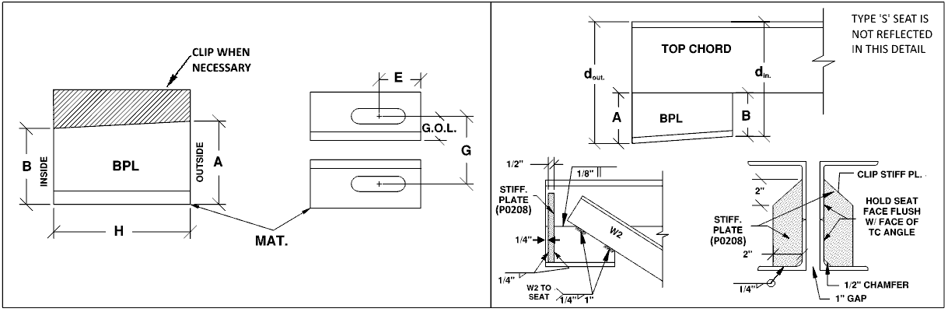
 |  |  |  |  |  | SLOTS
Qty | Mark(s) | MAT. | H | A | B | E | GOL | S | d_{out} | d_{in} | Stiff. Length
2 | G13 LE | 4050 | 6 | 1 1/2 | 1 1/2 | 3 1/2 | 1 15/16 | 13/16 x 2 | 7 1/2 | 7 1/2 | 5 1/2
2 | G13 RE | 4050 | 6 | 1 1/2 | 1 1/2 | 3 | 1 15/16 | 13/16 x 2 | 7 1/2 | 7 1/2 | 5 1/2

